The Luminescence Properties of Eight Periods In_{0.2}Ga_{0.8}N/GaN Multiple Quantum Wells with Silicon Doping in the First Two to Five Barriers of Blue LEDs

Yung-Chen Cheng^{1,}* and Meng-Chu Chen²
¹ Department of Materials Science, National University of Tainan, Tainan, 70005, Taiwan
²Department of Applied Science, National Taitung University, Taitung, 950, Taiwan

Abstract
We have been carrying out researches on luminescence properties of first two to five barriers in the growth sequence with silicon (Si) doping of eight periods In_{0.2}Ga_{0.8}N/GaN quantum wells (QWs) and we have published papers in Journal of Luminescence, Vol. 177, pp. 59–64, 2016. This paper provides more information on their properties. Epilayers are grown by low pressure metal-organic chemical vapor deposition (LPMOCVD) system on patterned sapphire substrates (PSSs). For the sample’s QWs containing first four barriers with Si doping, photoluminescence (PL) demonstrates the strongest intensity and relative larger spectral linewidth than other samples. It is originated from the increase of radiative recombination centers due to the effective reduction of quantum confined Stark effects (QCSE) and enhancements of carrier localization inside QWs. Higher output power and external quantum efficiency (EQE) are also shown in this blue LED. Soft confinement among QWs leads to reduction of Auger processes, leakage of carriers out of QWs, and nonradiative recombination centers in this sample. First four barriers with Si doping is the favorable doping condition for eight periods In_{0.2}Ga_{0.8}N/GaN QWs.
Keywords -- InGaN/GaN quantum wells (QWs), Silicon (Si) doping, Soft confinement potential, Quantum-confined Stark effect (QCSE), Auger processes, External quantum efficiency (EQE)

I. INTRODUCTION

InGaN/GaN quantum wells (QWs) is highly efficient luminescence material nanostructures that facilitates the realization of high brightness and energy-saving blue and white light light-emitting diodes (LEDs) [1,2]. In the past two decades, lots of researches on characteristics of InGaN/GaN QWs have been carried out. InGaN ternary compound is composed of binary alloys InN and GaN. Strain induced piezoelectric (PZ) field and compositional fluctuations of indium are occurred in InGaN due to large lattice mismatch and miscibility gap of InN and GaN [3-6].
In Fig. 1, InGaN/GaN QWs with PZ field the band edge is tilted and the separation of carriers i.e. Quantum-confined Stark effect (QCSE) take place. This causes weak radiative recombination of the electrons and holes shown in thin and pink dash line. For the QWs having screening of PZ field by excess electrons from dopant Si, the energy band edge does not tilt. Carriers are not separated in different side of QWs. The radiative recombinations are relatively easier shown in thick and pink dash line. It is noted that the lowest transition energy for optical emission in QWs without PZ field is larger than the value of QWs with PZ field. Blue shift of PL spectra peak energy occurs in the reduction of QCSE.
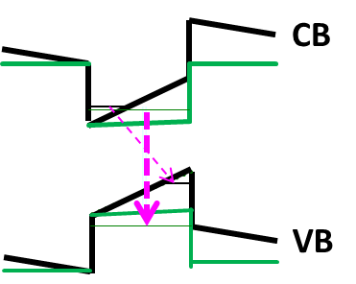
Fig. 1 InGaN/GaN QWs with and without piezoelectric field of the energy band structure shown in black and green lines and the corresponding radiative recombination displayed in thin and thick pink dash lines.

Inhomogeneous distribution of indium in InGaN/GaN QWs could also produce localized energy states acting as luminescence centers preventing the traps of carriers in non-radiative defects in particular for high indium content QWs. Indium-rich structures have deep localized states. Weaker piezoelectric field inside QWs accompanies with the formation of indium-rich deep localized states. Variations of peak position of PL spectra are relatively large in QWs without deep localized states. Carrier dynamics in InGaN/GaN QWs with compositional fluctuations is studied with time-resolved photoluminescence (TRPL) experiments and Monte Carlo simulations of exciton hopping and recombination in our previous report. An increasing trend of TRPL decay time on the high-energy side of the PL spectrum is observed in the QWs with Si-doped barriers having high nanocluster density. Such a trend is not observed in another sample with few clusters. This difference is consistent with the simulation results. The simulation results demonstrated that the increasing behavior of the PL decay time was due to the exciton trapping by the local potential minima in the spectral range of the free-carrier states [7-9]. Fig. 2 is the schematic diagram of soft
confinement potential energy among QWs and potential fluctuation inside QWs. E_{A} is the activation energy of QW.
The energy gap of samples can be roughly estimated. The precise value of bandgap is hard to calculate because the inhomogeneous distribution of indium and the strain in InGaN are not easy to quantify. This figure is used in explanations of motion of carriers and trapping of carriers in deep localized states in potential fluctuation QWs.

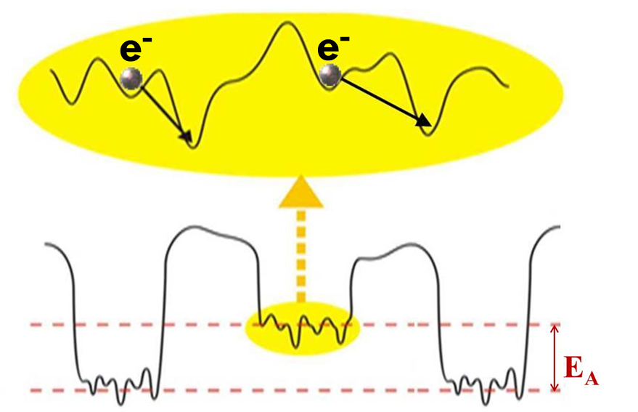
Fig. 2 Soft confinement among QWs and potential fluctuation inside QWs.

Si-doped GaN barriers can kindle screening of the strain induced piezoelectric (PZ) field and reduce quantum-confined Stark effect (QCSE) in InGaN/GaN QWs [10]. It also causes modifications of material nanostructure and formations of nanoscale indium rich islands [11], fluctuation of indium composition [12], blocking of injection of holes [13], etc. We have shown that whole barrier with Si doping has superior optical performance than whole well-doped InGaN QWs having high indium content of green luminescence LED [8]. Researchers tend to concentrate on the doping characteristics of whole barriers or wells. Part of barriers possessing Si doping in many periods of InGaN/GaN QWs of blue LED at high current injection have not been well addressed.
Blue LEDs with InGaN/GaN nowadays suffer the problem of quick reduction in luminous efficiency with the increase of injection current density in several ten A/cm² [14-30]. This obstacle makes it difficult to produce high-brightness in the application of white light LED. Several mechanisms including Auger processes in QWs [14-19], escape of carriers out of QWs [20-30] and non-radiative recombination centers (dislocations) [31] are responsible for this quick drop of external quantum efficiency (EQE) phenomenon at high injected carriers. To promote EQE of InGaN/GaN blue LEDs for high current injection, many methods were reported. Smooth confining potentials of InGaN/GaN QWs [18] and linear decrease of indium composition along the growth direction of InGaN wells [19] can avoid plenty of carriers accumulated near the first several wells in the injection direction of QWs leading to better spread of carriers among QWs. Instead of conventional GaN barriers, gradual decrease of composition of indium from 5 to 0 % along growth direction of InGaN barriers can improve hole transport and EQE droop [27]. Uniform carrier distribution and low Auger recombination rate shown in asymmetric triangular confining potential of QWs can also contribute to high EQE [28]. Confining potential of QWs is an crucial role in improving the EQE droops. EQE droop property of blue GaN LEDs can be improved by nine periods of QWs on a PSS [29]. InGaN/GaN QWs LEDs have the best optical and electrical performances if the active region consists of twelve QWs for the injection current 42 A/cm² [30]. In this report, we present the luminescence properties of eight periods In_{0.2}Ga_{0.8}N/GaN QWs with first two to five barriers in the growth sequence possessing Si doping of blue LEDs.
II. MATERIALS AND METHODS
Samples were grown on c-plane (0001) patterned sapphire substrates (PSSs) by horizontal reactor of commercial low pressure metal-organic chemical vapor deposition (LPMOCVD) system. The schematic drawing of material structure is shown in Fig. 3. Pyramid structures of PSSs have diameter, height, and interval of 2, 1.5, and 1 m, respectively. Metal-organic precursors include Tri-Methyl-Gallium (TMGa), Tri-Methyl-Indium (TMIn), and Tri-Methyl-Aluminum (TMAl). Gaseous NH₃ were used as vapour-phase precursors of elemental Gallium (Ga), Indium (In), Aluminum (Al), and nitrogen (N), respectively. Silane (SiH₄) and bis-cyclopentadienyl magnesium (Cp₂Mg) were precursors of the elemental Si and Mg as the dopant of the n- and p-type GaN, respectively. Mixture of hydrogen H₂ and nitrogen N₂ have ratio 1:1 which is chemically nonreactive acting as carrier gas of precursors.
Substrates were preheated at 1150 ºC in the hydrogen ambience. 3-µm-thick un-doped GaN (u-GaN) and then 3.3-µm-thick n-type GaN (n-GaN) with Si doping concentration 10¹⁹ cm⁻³ determined by second ion mass spectroscopy (SIMS) were grown. In_{0.02}Ga_{0.98}N/GaN superlattice with 2 nm/2 nm thick were subsequently deposited acting as strain relief layers (SRLs) to reduce the strain from the epilayers on PSSs. Eight pairs of In_{0.2}Ga_{0.8}N/GaN QWs with well and barrier thickness about 2.5 and 8 nm were grown at 750 and 900 ºC, respectively.
First two, three, four, and five barrier in the growth sequence of QWs layers having Si doping are named sample A, B, C, and D, respectively. Doping concentration of barriers was around 3×10¹⁷ cm⁻³. p-type Al_{0.16}Ga_{0.84}N with thickness 20 nm having magnesium (Mg) doping and grown at 950 ºC as electron blocking layer (EBL). 100 nm p-GaN window layer was grown on EBL. Finally, heavy Mg-doped GaN (p+-GaN) contact layer with doping concentration 1020 cm-3 was deposited at 950 ºC and thickness about 20 nm.
Fabrication processes of blue LED can be found in our recent reports [32]. Epilayers were etched selectively to the n-GaN layer. Indium tin oxide (ITO) was deposited onto p+-GaN surface by electron beam evaporator acting as transparent contact layer (TCL). Contact electrode Cr/Pt/Au multi-metal layers were deposited on the p+-GaN and n-GaN surfaces at the same time for good ohmic contact. Wafers were lapped and polished down to about 120 µm for chip dicing. Each LED devices with square chip and size of 1 mm² are produced.
The output power (P_{out}) of electroluminescence (EL) and EQE at room temperature (RT) versus the high current injection from 100 to 300 mA of the LEDs were measured. Optical pump luminescence properties of materials were also characterized by the measurements of photoluminescence (PL) at RT. Monochromator was used to disperse the white light from xenon lamp into a various monochromatic excitation lights with low pumping power (< 1 mW) in the measurements of PL.

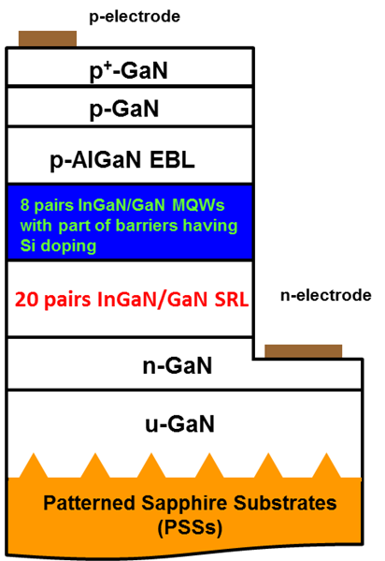
Fig. 3 Schematic diagram of blue LED structures. This schematic drawing of epitaxial layer thicknesses are exaggerated for clarity and are not to scale.

III. RESULTS AND DISCUSSION

Fig. 4(a)-(d) show the PL spectra of samples. The excitation wavelength of light of PL is set at 350 nm (3.54 eV) which is above the bandgap energy (3.44 eV) of GaN barrier. The emission peak energy of PL for the undoped barrier sample is 2.68 eV. Blue shifts of emission peak energies of all barrier-doped samples are demonstrated. It implies that QCSE in QWs are diminished through Si-doped barriers. Variations of peak energies of PL spectra are originated from different degree of fluctuations of indium in QWs. Sample C shows the highest peak intensity and its intensity is normalized. Spectral linewidth of PL of samples A, B, C, and D are 131, 133, 156, and 127 meV, respectively. Sample C shows relatively larger spectral linewidth than other samples.
Fig. 5 and 6 show the output power (P_{out}) and EQE versus the injection currents from 100 to 300 mA of blue LED. In Fig. 3, the increase trend of the P_{out} as the injection current is increased can be observed in all samples. Sample C exhibits larger P_{out} when compared with other samples. In Fig. 4, all samples show the drop of EQE as the injection current is raised. Sample C has larger values of EQE in the whole range of injection current than others.
Linewidth of PL spectra can provide important information on the quality of QW interface because QWs are very sensitive to interface roughness. Fluctuations of one atomic monolayer can alter the carrier confinement energy of QWs considerably. A general broadening of the PL spectrum is usually observed when the QW thickness varies. Variations of the optical emission wavelength of InGaN/GaN QWs can correlate with the Si doping profile in QWs. Increases in the Si doping level leads to blue shift in emission energy due to mitigation of the QCSE in QWs. Spatial distributions of electrons and holes experience redistribution by Si dopant in different positions in InGaN/GaN QWs [33] can take place.
Fig. 4 PL spectra of samples at room temperature.
Fig. 5 LED output power (Pout) of samples as a function of injection current.
Fig. 6 External quantum efficiency (EQE) of samples as a function of injection current.

Fig. 7(a) and (b) are the illustrations of QW band diagram with carrier distribution among eight QWs without piezoelectric field for regular and soft confinement QWs. In the figure, the wider FWHM and stronger PL peak intensity are due to more uniform distribution of carriers among eight QWs in sample C. Sample C shows relatively larger degree of modulation of QWs through Si doping than others. The formation of stronger carrier localization inside QWs and soft confinement of carriers among eight QWs are suggested in sample C. It also leads to larger P_{out} and higher values of EQE in sample C. It should be noted that the use of PSSs and SRLs can have contribution to the reduction of PZ field in QWs. In view of the luminescence behaviors, first four barriers with Si doping is the better condition in concerning superior optical performance for eight periods In_{0.2}Ga_{0.8}N/GaN QWs of blue LEDs under high carrier injection.

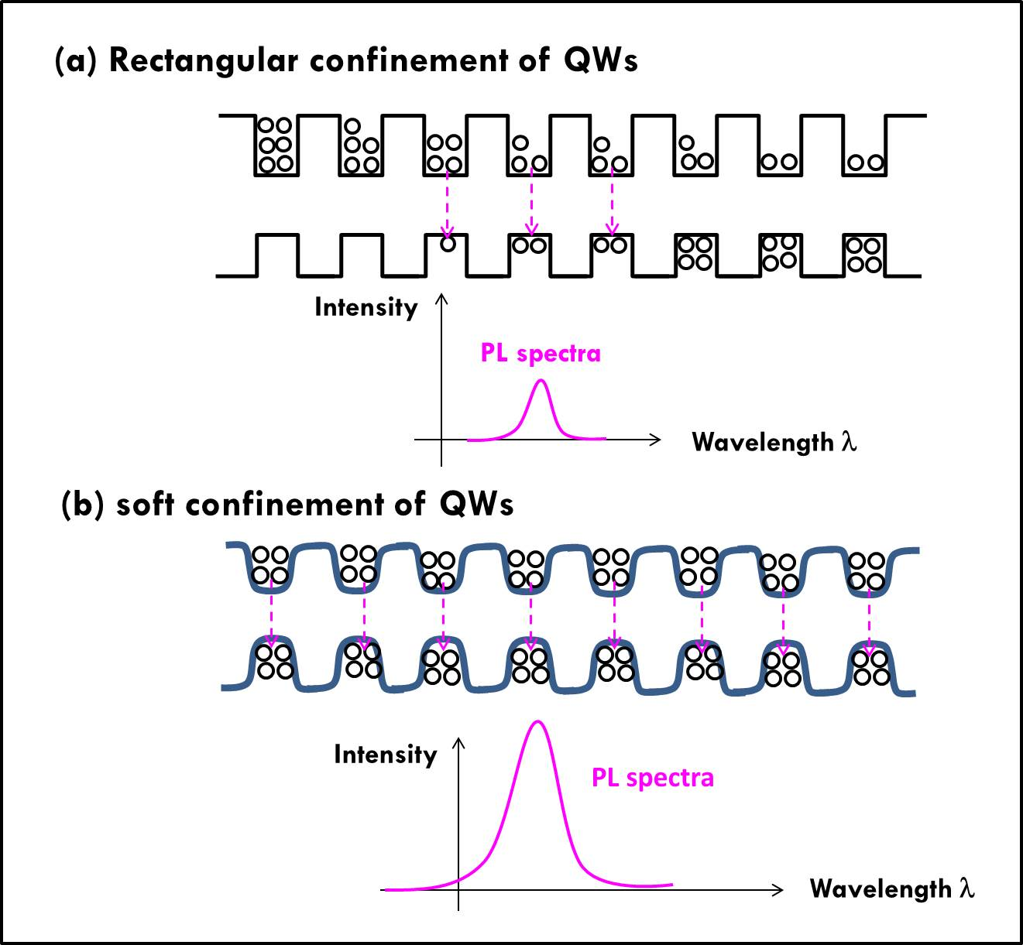

Fig. 7(a) and (b) QW band diagram with carrier distribution among eight QWs without piezoelectric field for regular and soft confinement QWs.

IV. CONCLUSIONS

Luminescence behaviors of eight periods In0.2Ga0.8N/GaN QWs with first two to five barriers in the deposition sequence containing Si doping of blue LEDs were studied. Soft confinement of QWs potential accompany with stronger carrier localization inside QWs were suggested in QWs with first four barriers with Si doping. That features cause more uniformity of carrier distribution among QWs and high radiative recombination of carriers inside QWs. Increase of output power and EQE is related to decrease of non-radiative recombination centers, non-radiative Auger processes, and leakage of carriers out of QWs in the blue LEDs with QWs having first four barriers with Si doping. The results in this research could better enhance the knowledge in optimal conditions of the number of barriers with Si doping for high emission intensity of blue LEDs .

V. ACKNOWLEDGMENT
This work was correlated with revised Grant Proposal No. 103WFA0F00165 submitted to Ministry of Science and Technology and was financially supported in part by the National University of Tainan.

VI. REFERRENCES
- I. Akasaki and H. Amano, “Breakthroughs in improving crystal quality of GaN and invention of the p-n junction blue-light-emitting diode”, The Japanese Journal of Applied Physics, 45, 9001, 2006.
[2] S. Nakamura, Y. Harada, and M. Seno, “Novel metalorganic chemical vapor deposition system for GaN growth”, Applied Physics Letters, 58, 2021, 1991.
[3] K.P. O’Donnell, R.W. Martin, and P.G. Middleton, “Origin of luminescence from InGaN diodes”, Physical Review Letters, 82, 237, 1999.
[4] H. Chen, R.M. Feenstra, J.E. Northrup, T. Zywietz, and J. Neugebauer, “Spontaneous formation of indium-rich nanostructures on InGaN (0001) surfaces”, Physical Review Letters, 85, 1902, 2000.
[5] P. Waltereit, O. Brandt, J. Ringling, and K.H. Ploog, “Electrostatic fields and compositional fluctuations in (In,Ga)N/GaN multiple quantum wells grown by plasma-assisted molecular-beam epitaxy”, Physical Review B, 64, 245305-1, 2001.
[6] O. Mayrock, H.-J. Wünsche, and F. Henneberger, “Polarization charge screening and indium surface segregation in (In,Ga)N/GaN single and multiple quantum wells”, Physical Review B, 62, 16870, 2000.
[7] K. Kazlauskas, G. Tamulaitis, P. Pobedinskas, A. Žukauskas, M. Springis, C.-F. Huang, Y.-C. Cheng, and C.C. Yang, “Exciton hopping in In_{x}Ga_{1−x}N multiple quantum wells”, Physical Review B, 71, 085306-1, 2005.
[8] Y.-C. Cheng, E.-C. Lin, C.-M. Wu, C.C. Yang, J.-R. Yang, A. Rosenauer, K.-J. Ma, S.-C. Shi, L.C. Chen, C.-C. Pan, and J.-I. Chyi, “Nanostructures and carrier localization behaviors of green-luminescence InGaN/GaN quantum-well structures of various silicon-doping conditions,” Applied Physics Letters, 84, 2506, 2004.
[9] Y-C Lu, C-Y Chen, H-C Wang, C.C. Yang, and Y-C Cheng, “Carrier trapping effects on photoluminescence decay time in InGaN/GaN quantum wells with nano-cluster structures”, Journal of Applied Physics, 101 (2007) 063511-1.
[10] J. Dalfors, J.P. Bergman, P.O. Holtz, B.E. Sernelius, B. Monemar, H. Amano, and I. Akasaki, “Optical properties of doped InGaN/GaN multiquantum-well structures”, Applied Physics Letters, 74, 3299, 1999.
[11] K. Uchida, T. Tang, S. Goto, T. Mishima, A. Niwa, and J. Gotoh, “Spiral growth of InGaN/InGaN quantum wells due to Si doping in the barrier layers”, Applied Physics Letters, 74, 1153, 1999.
[12] T. Deguchi, A. Shikanai, K. Torii, T. Sota, S. Chichibu, and S. Nakamura, “Luminescence spectra from InGaN multiquantum wells heavily doped with Si”, Applied Physics Letters, 72, 3329, 1998.
[13] E.-H. Park, D.N.H. Kang, I.T. Ferguson, S.-K. Jeon, J.-S. Park, and T.-K. Yoo, “The effect of silicon doping in the selected barrier on the electroluminescence of InGaN/GaN multiquantum well light emitting diode”, Applied Physics Letters, 90, 031102-1, 2007.
[14] J. Iveland, L. Martinelli, J. Peretti, J.S. Speck, and C. Weisbuch, “Direct measurement of Auger electrons emitted from a semiconductor light-emitting diode under electrical injection: identification of the dominant mechanism for efficiency droop”, Physical Review Letters, 110, 177406-1, 2013.
[15] C.-H. Lin, C.-Y. Su, Y. Kuo, C.-H. Chen, Y.-F. Yao, P.-Y. Shih, H.-S. Chen, C. Hsieh, Y.-W. Kiang, and C.C. Yang, “Further reduction of efficiency droop effect by adding a lower-index dielectric interlayer in a surface plasmon coupled blue light-emitting diode with surface metal nanoparticles”, Applied Physics Letters, 105, 101106, 2014.
[16] E. Kioupakis, P. Rinke, K.T. Delaney, and C.G. Van de Walle, “Indirect Auger recombination as a cause of efficiency droop in nitride light-emitting diodes”, Applied Physics Letters, 98, 161107-1, 2011.
[17] Y.C. Shen, G.O. Mueller, S. Watanabe, N.F. Gardner, A. Munkholm, and M.R. Krames, “Auger recombination in InGaN measured by photoluminescence”, Applied Physics Letters, 91, 141101-1, 2007.
[18] R. Vaxenburg, E. Lifshitz, and Al.L. Efros, “Suppression of Auger-stimulated efficiency droop in nitride-based light emitting diodes”, Applied Physics Letters, 102, 031120-1-5, 2013.
[19] Z.-H. Zhang, W. Liu, Z. Ju, S.T. Tan, Y. Ji, Z. Kyaw, X. Zhang, L. Wang, X.W. Sun, and H.V. Demir, “InGaN/GaN multiple-quantum-well light-emitting diodes with a grading InN composition suppressing the Auger recombination”, Applied Physics Letters, 105, 033506-1, 2014.
[20] J. Xie, X. Ni, Q. Fan, R. Shimada, U. Ozgur, and H. Morkoc, “On the efficiency droop in InGaN multiple quantum well blue light emitting diodes and its reduction with p-doped quantum well barriers”, Applied Physics Letters, 93, 121107-1, 2008.
[21] S. Choi, M.-H. Ji, J. Kim, H.J. Kim, Md.M. Satter, P.D. Yoder, J.-H. Ryou, R.D. Dupuis, A.M. Fischer, and F.A. Ponce, “Efficiency droop due to electron spill-over and limited hole injection in III-nitride visible light-emitting diodes employing lattice-matched InAlN electron blocking layers”, Applied Physics Letters, 101, 161110-1, 2012.
[22] Y.Y. Zhang and Y.A. Yin, “Performance enhancement of blue light-emitting diodes with a special designed AlGaN/GaN superlattice electron-blocking layer”, Applied Physics Letters, 99, 221103-1, 2011.
[23] S.-C. Ling, T.-C. Lu, S.-P. Chang, J.-R. Chen, H.-C. Kuo, and S.-C. Wang, “Low efficiency droop in blue-green m-plane InGaN/GaN light emitting diodes”, Applied Physics Letters, 96, 231101-1, 2010.
[24] Y.-K. Kuo, J.-Y. Chang, M.-C. Tsai, and S.-H. Yen, “Advantages of blue InGaN multiple-quantum well light-emitting diodes with InGaN barriers”, Applied Physics Letters, 95, 011116-1, 2009.
[25] X. Ni, Q. Fan, R. Shimada, Ü. Özgür, and H. Morkoç, “Reduction of efficiency droop in InGaN light emitting diodes by coupled quantum wells”, Applied Physics Letters, 93, 171113-1, 2008.
[26] M.F. Schubert, J. Xu, J.K. Kim, E.F. Schubert, M.H. Kim, S. Yoon, S.M. Lee, C. Sone, T. Sakong, and Y. Park, “Polarization-matched GaIn/AlGaInN multi-quantum-well light-emitting diodes with reduced efficiency droop”, Applied Physics Letters, 93, 041102-1, 2008.
[27] C.H. Wang, S.P. Chang, P.H. Ku, J.C. Li, Y.P. Lan, C.C. Lin, H.C. Yang, H.C. Kuo, T.C. Lu, S.C. Wang, and C.Y. Chang, “Hole transport improvement in InGaN/GaN light-emitting diodes by graded-composition multiple quantum barriers”, Applied Physics Letters, 99, 171106-1, 2011.
[28] C.-Y. Chang, H. Li, and T.-C. Lu, “High efficiency InGaN/GaN light emitting diodes with asymmetric triangular multiple quantum wells”, Applied Physics Letters, 104, 091111-1, 2014.
[29] S. Tanaka, Y. Zhao, I. Koslow, C.-C. Pan, H.-T. Chen, J. Sonoda, S.P. DenBaars, and S. Nakamura, “Droop improvement in high current range on PSS-LEDs”, Electronics Letters, 47, 335, 2011.
[30] C.S. Xia, Z.M.S. Li, Z.Q. Li, Y. Sheng, Z.H. Zhang, W. Lu, and L. W. Cheng, Optimal number of quantum wells for blue InGaN/GaN light-emitting diodes, Applied Physics Letters, 100, 263504-1, 2012.
[31] G. Pozina, R. Ciechonski, Z. Bi, L. Samuelson, and B. Monemar, “Dislocation related droop in InGaN/GaN light emitting diodes investigated via cathodoluminescence”, Applied Physics Letters, 107, 251106-1, 2015.
[32] J.-J. Dai, C.-F. Lin, G.-M. Wang and M.-S. Lin, “Enhanced the light extraction efficiency of an InGaN light emitting diodes with an embedded rhombus-like air-void structure”, Applied Physics Express, 3 71002-1, 2010.
[33] J.T. Griffiths, S. Zhang, B. Rouet-Leduc, W. Y. Fu, A. Bao, D. Zhu, D.J. Wallis, A. Howkins, I. Boyd, D. Stowe, M.J. Kappers, C.J. Humphreys, and R. A. Oliver, “Nano cathodoluminescence reveals mitigation of the Stark shift in InGaN quantum wells by Si doping”, Nano Letters, 15, 7639, 2015.

